**Brooklyn torah gazette**

**For Parshas Tzav 5779**

Volume 3, Issue 30 (Whole Number 126) 16 Adar Sheni 5779/ March 23 2019

**Printed L’illuy nishmas Nechama bas R’ Noach, a”h**

For a free subscription, please forward your request to [***keren18@juno.com***](mailto:keren18@juno.com)

**R’ Moshe de Leon, zt”l**

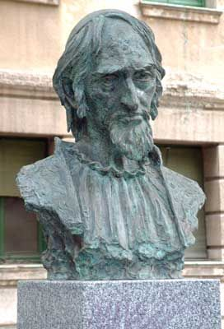

Rabbi Moshe de Leon, zt”l was born approx. 1250 – died 1305 R’ Moshe ben Yom Tov de Leon was born in Leon, Spain. He was the author of a number of works on kabbalah, and was an opponent of philosophy.

R’ Moshe earned his living as a traveling scribe, copying old manuscripts. On one of his trips he discovered the Zohar, the kabbalistic midrash traditionally ascribed to the sage of the mishnah, Rabbi Shimon bar Yochai.

The 18th century halachic authority, kabbalist, bibliographer and traveler, R’ Chaim Yosef David Azulai (“Chida”), writes that the Zohar was lost not long after R’ Shimon bar Yochai and his son passed away.

Centuries later, it was uncovered by an “eastern king” who sought, in vain, a scholar who could decipher it. Not until the manuscript reached the Jews of far-away Toledo, Spain, could anyone make sense of the work.

The Chida also quotes a sage who wrote that the Zohar was hidden in the library of the University of Heidelberg, Germany until it was uncovered there. (Interestingly, Chida does not mention R’ Moshe in connection with the Zohar.) Many opponents of kabbalah have claimed that R’ Moshe himself was the author of the Zohar. It has been shown, however, that R’ Moshe’s own kabbalistic teachings, as found in his works, do not comport with those of the Zohar. (The Artscroll Rishonim Shem Ha’gedolim: Erech Zohar-Hamaayan

*Reprinted from the Parashat Tzav 5779 email of whY I Matter, the Young Israel of Midwood (Brooklyn) parsha sheet edited by Yedidye Hirtenfeld.*

**The Shmuz on****Parshas Tzav**

**Ours is to Question Why…**

**By Rabbi Bentzion Shafier**

**Founder of TheShmuz.com**

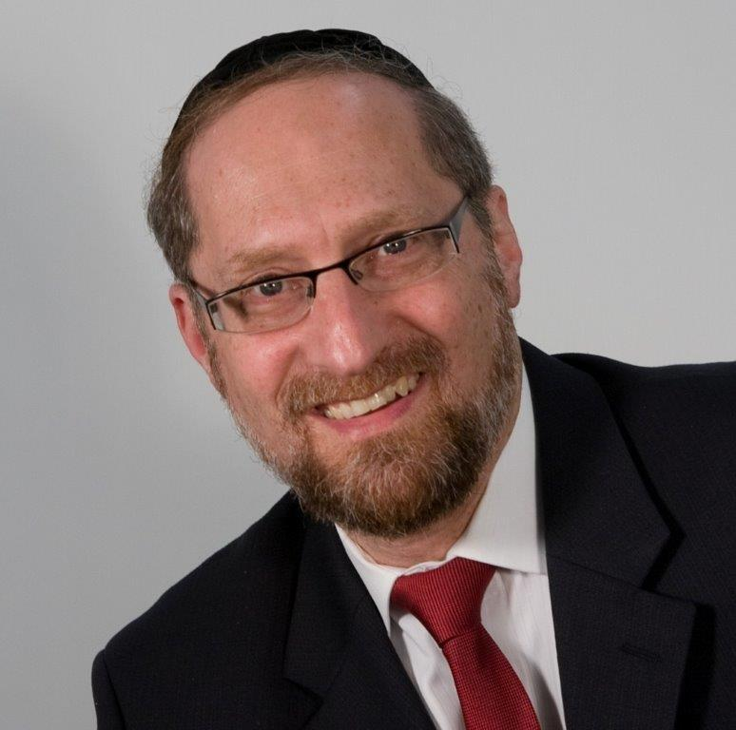

“*And Aharon and his sons carried out all the matters that HASHEM commanded through Moshe*.” — Vayikra 8:36

After a long and detailed description of the avodah (service) to be done in the Mishkan, the parshah ends by telling us that “Aharon and his sons did as they were told.”

Rashi seems to be bothered by how obvious this statement is. Of course Aharon did what HASHEM told him to do! Why is it necessary to say so? Rashi explains that the Torah includes it as a statement of praise: Aharon and his sons didn’t veer off to the right or to the left.

This Rashi is difficult to understand. It doesn’t seem like he answered his question. Of course, Aharon didn’t veer off to the left or the right. This was the avodah in the Mishkan that he was performing, and the directives came straight from HASHEM. Would he possibly think that he knew better than HASHEM how to perform the service? If that wasn’t reason enough, the Torah tells us repeatedly that the punishment for a Kohen who deviates from the avodah is death.

Imagine a man working with high voltage electrical equipment. He has been given clear safety instructions. Make sure the power is off before you switch on the transformer. Make sure that you are wearing protective gloves and that you are grounded. Wouldn’t we expect him to follow every nuance because of the danger involved?

So what type of praise is this? The answer to this question can be best understood with an example.

**In the Image of HASHEM**

There is a story told about an Englishman who visited a farm in Texas in the 1880’s. As he approached the ranch, he saw a cowboy herding the cows. He asked to see the cowboy’s boss. In doing so, he used an expression common in England then: “Is your master at home?”

The cowboy put both hands on his hips and proclaimed, “The son of a gun ain’t been born yet.”

This anecdote is illustrative of a very human trait: we don’t like to be bossed around. In fact, we hate it. I’ll gladly help you, I’ll do anything for you — but ask nicely. Boss me around and forget it. I’m out of here.

This isn’t just a quirk of human nature. It’s a direct outgrowth of man’s inherent greatness.

Chazal explain that when the Torah writes that HASHEM created man in His image, it isn’t merely an expression. Man is both the reason for all of existence and the maintainer of it. Everything physical has a spiritual counterpart sustaining it.

HASHEM put man into the role of being the one who upholds the spiritual level of the world. His actions, deeds, and thoughts build upper worlds and sustain the lower worlds. Our eyes may not be attuned to it, but man is the maintainer of physicality. He is more significant than we can ever imagine, more important than anything we can envision. He is a little creator.

**Bosses Don’t Like Being Bossed Around**

While this greatness of soul allows man to reach dizzying heights, it also comes with a liability. It is very difficult for us to follow orders. Even when we know that they are right. Even when we know that they are good for us. Even when those orders are given by the greatest of all greats, by the Creator of the heavens and the earth. We don’t like taking orders.

This seems to be the answer to the question on Rashi.

Aharon was one of the greatest men who ever lived, and he had a high and lofty sprit. As such, it should have been very difficult for him to follow orders. For him, “doing as he was told” should have been very hard. Nevertheless, it wasn’t. He was exceedingly humble, so he was able to recognize his greatness and act in a bold and innovative manner when it was called for, yet accept that HASHEM was in charge. As great as he was, he was but a servant in front of his Master. He had overcome one of the paramount challenges to man — recognizing his greatness yet remaining humble.

Understanding this balance is critical for our growth. The Torah wasn’t given to robots, or for people to follow it blindly without understanding. We are expected to ask questions and delve into the reasoning behind things. We are obligated to strain our minds to the best of our ability in the process. And yet, we are expected to yield to the superior wisdom of our Creator and to humbly submit to His directives. Ours is to question why, and yet ours it to do or die.

*Reprinted from this week’s website on TheShmuz.com This is an excerpt from the [Shmuz on the Parsha book](https://theshmuz.com/product/shmuz-on-the-parsha-book/).*

**Rabbi Berel Wein**

**On Parashat Tzav**

The daily permanent sacrifice that was offered in the Temple in Jerusalem and previously in the Tabernacle in the desert was called ‘olah.’ It was an offering that went completely to Heaven, so to speak, and was offered every morning and evening of each day of the year.

It differed from other types of sacrifices in that it was consumed completely on the altar and no human being, not the priest who was the officiant or the person who, in certain cases, donated the sacrifice, had any direct physical benefit from the offering.

The public sacrifice that was brought twice a day came from public funds while the Torah allowed individuals who wished to, to donate this type of sacrifice. But the outstanding feature of this type of sacrifice was that no human being derived any physical benefit. Even when performing a positive commandment of the Torah, there always is an element of benefit and pleasure that accrues to the one performing the act.

Even though the Talmud discusses whether physical pleasures are allowed to be derived from performing commandments of the Torah, it is understood that when it comes to the offering of the sacrifice of the olah, even abstract pleasure and benefit is somehow not present. This type of sacrifice represents the ultimate in human service to the Divine without it being tarnished by personal gain and benefit.

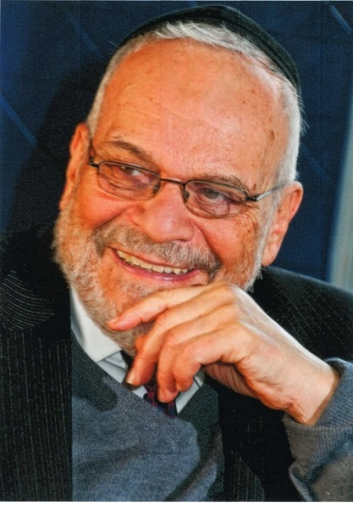

**Rabbi Berel Wein**

The Torah is aware of the difficulty of coercing altruism on the part of human beings. Physically, spiritually and psychologically, we always have factors that influence us even when we are engaged in doing noble deeds and fulfilling positive commandments. The Torah comes to channel these factors but not to deny or to pretend that they are not part of the human makeup.

As such, we see that in all other types of sacrifices that were offered in the Temple, there was some sort of physical human benefit, whether to the priest who officiated in bringing the sacrifice and even to the donor whose dollars brought the sacrifice to the Temple.

There were strict and detailed instructions as to what benefit could be had and in what state of purity the person who benefited from it had to be. This is always the pattern in the Torah, when it gives instructions as to how to conduct oneself in the physical world. We humans get practice in the necessary restraint that makes us special and not just another form of the animal kingdom.

However, the public sacrifices that were to be brought twice daily and would represent the Jewish people to its Creator, were meant to create an aura of altruism that would endow the Jewish public generally and the Temple service particularly with the required measure of holiness and devotion. And this could be achieved only by the constant repetition of offering the sacrifice of the olah.

*Reprinted from this week’s website of Rabbiwein.com*

**Don’t Let the Rain**

**Put Out the Fire**

**Rabbi Eli J. Mansour**

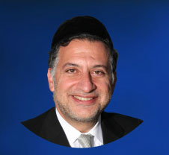

In Parashat Tzav (6:6) the Torah tells that the fire on the altar of the Bet Ha'mikdash would burn constantly, without interruption.  The Rabbis tells us that it would occasionally rain over the altar, which was situated outdoors, in the courtyard of the Bet Ha'mikdash, but miraculously the fire continued burning.

What practical lesson is there for us to learn from this miracle? If G-d wanted to ensure that the fire would not be extinguished, He could have saw to it that it would never rain over that spot.  Why did He perform this particular miracle, that the fire continued burning in the rain?

There is an answer to this question that is of great practical value to us. The fire on the Mizbei'ach (altar) symbolizes the fire of enthusiasm and excitement within each and every Jew that motivates him to serve G-d, to perform Mitzvot. There is a spark within each of us that inspires us to act as we should.

But there are many people in the world who try to extinguish that flame, to put a damper on the fire of enthusiasm and inspiration within us.  So often it happens that a person decides to start attending Torah classes, until a friend tells him or her, "What are you wasting your time for?" or "They're just trying to brainwash you." Or a woman may decide to dress modestly, only to hear a friend mocking her and telling her how poorly she looks. These comments are the "rain" that comes down and tries to extinguish the spiritual flame.

The Torah therefore tells us that the rain could never put out the fire on the altar. We, too, must never let the cynics, critics and naysayers put a damper on our inspiration and spiritual ambition.  More often than not, the cynics make these disparaging remarks because they cannot bear to see others achieve more than they do.  It is far easier to destroy than to build, and so rather than build themselves, they try to protect their ego by destroying others. And besides, usually after the cynic makes this comment he returns to his own affairs and forgets about what he had said.  One mustn't lend more credence to a cynical remark than the person who made it does.

Just like the fire on the altar, we must ensure that our "fire" of excitement and fervor for Mitzvot continues to burn even when others try to put it out.

*Reprinted from this week’s website of the Edmund J. Safra Synagogue in Brooklyn, NY.*

**Esther’s Story**

**By Rabbi Moshe Meir Weiss**



The Gemora in Megillah teaches us that Esther requested, “Kavuni l’doros - Affix me for all generations,” please write my story for posterity.  This is a very strange request.  We know that a common denominator of all our great ones is that they shared a strong sense of humility - as the posuk states, “Eikev anava yiras Hashem - Besides humility, there is fear of G-d.”

Therefore, just like all of our leaders were G-d fearing, they were very humble as well.  That being the case, it seems quite puzzling that Esther would openly express a desire that she should be recorded publicly.  Why this desire to have her name ‘up in lights’ for all to read throughout the generations?

We can be certain that it was not a quest for fame that motivated Esther HaMalka.  One explanation of Esther’s desire for the accounts of Purim to be included in the Scriptures is that she recognized the timeless lessons of the story of Purim.

Thus, the lessons of giving and sharing that we learn from the mitzvahs of mishloach manos and matanos le’evyonim are of everlasting importance.  So too, the message of Jewish pride and the emphasis on the supremacy of learning and mitzvahs are expressed so vividly and eloquently in the verse, “LaYehudim haysah orah v’simcah v’soson v’ykar.” This verse is homiletically interpreted to mean that the Jews recognized the paramount light of the Torah, the true joy of the Festivals, the rejoicing of the mitzvah of milah, and the preciousness of the commandment of tefillin.

But, there is another reason Esther petitioned to have her story revealed to all. We must realize that Esther had to live a life that was the antithesis of the ambition of any good Beis Yakov girl.  The Yad Hashem forced her to do the unthinkable - to marry a gentile and to live with him publicly for many, many years; and to bear him a child, Darius the 2nd, who would become the next emperor of Persia.

Esther was concerned that history should know the true story - that she was propelled by Divine forces to be the instrument to save Klal Yisroel.  She wanted that, into the words of the Megillah, should be woven the true account of how she never succumbed to Achashveirosh willingly (cf. “Vatilokach Esther,” which means that she was coerced to go into Achashveirosh).  And indeed, Hashem acquiesced to Esther’s desire, as the Gemora says, “Esther b’Ruach HaKodesh nemra - The Megillah of Esther was truly Divinely inspired,” and as we know, it has been included among the twenty-four books of TaNa”CH.

This can also be the deeper meaning of the Gemora in Chullin [39b], “Esther min HaTorah minayin?” which, on the simple level, is taken to mean, “Where do we find a Scriptural reference to Esther in the Torah?”  However, now we can add another meaning to this question.  How do we know that Esther’s behavior was Biblically correct?

And thus the Gemora answers with the Biblical verse, “Anochi haster aster panai - I will conceal my presence (says Hashem).” (Both of the words, haster and aster, are etymologically similar to Esther.)  This is taken as a reference to the era of Mordechai and Esther, when the Divine hand seemed to be concealed and Haman and his cohorts almost succeeded in their nefarious plot to annihilate the Jewish People.  This is why Hashem’s name is not mentioned even once in the entire Megillah.

In his incredible sefer, Toras Chemed, Rav Michoel Ber Weismandel, zt”l, Zy”a, writes the most amazing Biblical source for Esther.  He reveals that there are 12,110 letters in Megillas Esther.  Then he says that if you count 12,110 from the first alef in the Torah, found in the word Bereishis, you come to a samech.  Then, if you count another 12,110 letters, you arrive at the letter tof.  Continuing again 12,110 more letters from the tof, one arrives incredibly at a reish - spelling the word Esther.

[What is also fantastic is the fact the he calculated this before the computer came into existence.] Is it any wonder that the Gemora tells us that the Chachomim ikrei Sofrim, the Sages were called Counters, for they calculated such incredible revelations such as this one?

Now we can also more easily understand why, if a sefer Torah is missing just one letter, the whole Torah is posul, rendered unfit, for it throws off myriads of such sequential calculations.

May it be the will of Hashem that in the merit of Mordechai and Esther, Hashem protect Klal Yisroel from all dangers, sickness, and woes, and may we all be zoche to long life good health, happiness and everything wonderful.

*Reprinted from the March 1, 2015 website of Matzav.com*

**The Thirteen Principles of Jewish Faith – Maimonides**

**Principle 1 - To know the existence of the Creator**

To believe in the existence of the Creator, and this Creator is perfect in all manner of existence. He is the cause of all existence. He causes them to exist and they exist only because of Him. And if you could contemplate a case, such that He was not to exist…then all things would cease to exist and there would remain nothing.

And if you were to contemplate a case, such that all things would cease to exist aside from the Creator, His existence would not cease. And He would lose nothing; and oneness and kingship is His alone. Hashem of strength is His name because He is sufficient with His own existence, and sufficient [is] just Him alone, and needs no other.

And the existences of the angels, and the celestial bodies, and all that is in them and that which is below them…all need Him for their existence. And this is the first pillar and is attested to by the verse, “I am Hashem your G-d.” (Elaboration on this principle)

**Principle 2 - The unity of G-d**

Meaning to say to accept that this is the quintessential idea of Oneness. It is not like the oneness of a pair (i.e. pair of shoes - one group) and not one like a species. And not like man that has many individual (members) nor like a body that divides into many different parts until no end (every part being divisible). Rather, G-d is one and there is no other oneness like His. This is the second principle and is taught in what it says, “Hear Israel, Hashem is Our G-d, Hashem is one.”

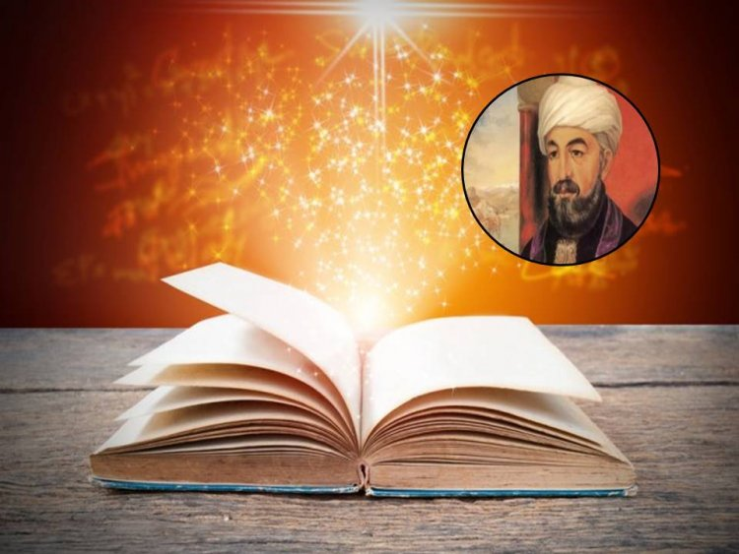

## According to Maimonides, these are the most important principles in Judaism that every Jew must know. The 13 Principles of Faith

**Principle 3 - The denial of physicality in connection with G-d**

This is to accept that this Oneness that we have mentioned above (Principle II) is not a body and has no strength in the body, and has no shape or image or relationship to a body or parts thereof. This is why the Sages of blessed memory said with regards to heaven there is no sitting, nor standing, no awakeness, nor tiredness. This is all to say that He does not partake of any physical actions or qualities.

And if He were to be a body then He would be like any other body and would not be G-d. And all that is written in the holy books regarding descriptions of G-d, they are all anthropomorphic.

Thus said our great Rabbis of blessed memory, “The Torah speaketh in man’s language” (i.e. using human terms to offer some understanding). And the Rabbis have already spoken at length on this issue. This is the third pillar and is attested to by the verse, “For you saw no image”meaning that you did not see an image or any form when you stood at Sinai because as we have just said, He has no body, nor power of the body.

**Principle 4 – G-d’s Antiquity**

This is that G-d existed prior to everything, and exists after everything. This is proved many times throughout scripture and is attested to by the verse, “Meuna Elokei kedem.”

**Principle 5 -** **That G-d, blessed be He is worthy that we serve Him, to glorify Him, to make known His greatness, and to do His commands**

But not to do this to those that are below Him in the creation. Not to the angels or to the stars or the planets or anything else, for they are all created things in nature and in their functioning, there is no choice or judgment except by G-d Himself.

Also it is not fitting to serve them as intermediaries to G-d. Only to G-d should you incline your thoughts and your actions. This is the fifth principle and it warns against idolatry and most of the Torah speaks out against this.

**Principle 6 – Prophecy**

And this is that it is known to man that this (prophet) is a type of man who are created beings of great stature and perfection of the character traits. Who have tremendous knowledge until a different intelligence attaches to them when the intelligence of the person clings to the intelligence of G-d and it rests upon him. And these are the prophets; and this is prophecy; and the idea of it. The explanation of it is very long and the intention is not to bring a sign for every fundamental and to explain it all, encompassing of all knowledge (i.e. G-d’s knowledge) but it is mentioned to us in a story form and all of the Torah attests to this.

**Principle 7 -** **The prophetic capacity of Moses our Teacher, peace be upon him**

And this is that we accept that he was the father of all prophets that were before him and that will be after him. He was on a qualitatively different level than any other, and he is chosen from all other people before and after him of any that have any knowledge of G-d; for his was the greatest. And he, peace be upon him, rose to the levels of the angels. He was granted all areas of knowledge and prophecy and his physical attributes did not diminish. His knowledge was different and it is through this difference that it is ascribed to him that he spoke to G-d without any intermediary or angel.

My intention was to explain this puzzling concept and to open up the sealed areas in the Torah regarding the verses of “face to face” and other similar references, but its length would be tremendous and it would require numerous proofs from the Torah and other sources and encompass many areas. Even to write it the briefest of briefest it would require 100 pages, so I will save it and write it in another book. I will now return to the intent of this seventh fundamental that the prophecy of Moses our teacher, peace be upon him, was different from all others in 4 ways:

1) Regarding all other prophets, G-d spoke to them through intermediaries. Regarding Moses, it was without one, as it says, “face to face I spoke to him”.

2) Regarding all other prophets, prophecy came to them at night while they were asleep in a dream as it says, “in a dream of the night” and other such references; or in the day but only after a deep sleep-like state came over them, and all their senses were shut off except their thoughts. Not so by Moses. Moses would receive a prophecy any time when he would stand between the two figures [fixed] on the ark, as G-d attests to it, “and I will make it known to you there” and “not so my servant Moses. Face to face I speak to him.”

3) When a prophet would receive prophecy he would not be able to stand the intense effect and he would shake and not be able to stand, as it relates regarding Daniel in his encounter with the angel Gabriel. Regarding Moses, he did not suffer from this. As it says, “Face to face do I speak to him as a person speaks to his friend”. And even though this is the greatest connection to G-d, still, he did not suffer.

4) All other prophets could not receive prophecy at their will, [but] only when G-d desired to tell them. Some would go days or months without prophecy. Even if they wanted or needed something, sometimes it would be days or months or years or even never that they would be told [a prophecy].

Some would have people play music to put them in a good mood such as Elisha. But Moses, peace be upon him, received prophecy whenever he wanted, as it says, “Stand here and listen to what G-d will tell you what to do” and “G-d said to Moses tell Aaron your brother that he can’t come to the holy of holies at any time [he wants]”.

Our rabbis said, “Aaron was prohibited to come whenever he wanted, but not Moses.

**Principle 8 - That the Torah is from heaven [G-d]**

And this is that you believe that all of this Torah that was given by Moses our teacher, peace be upon him, that it is all from the mouth of G-d. Meaning that it was received by him entirely from G-d. And it is not known how Moses received it except by Moses himself, peace be upon him, that it came to him. That he was like a stenographer that you read to him and he writes all that is told to him: all the events and dates, the stories, and all the commandments.

There is no difference between “And the sons of Cham were Kush, and Mitzraim, and his wife was Mehatbe’el” and “Timnah was his concubine” and “I am Hashem your G-d” and “Hear Israel [Hashem your G-d, Hashem is one]” for it was all given by G-d. And it is all Hashem’s perfect Torah; pure, holy, and true. And he who says that these verses or stories, Moses made them up, he is a denier of our sages and prophets worse than all other types of deniers [form of heretic] for he thinks that what is in the Torah is from man’s flawed heart and the questions and statements and the dates and stories are of no value for they are from Moses Rabbeinu, peace be upon him.

And this area is that he believes the Torah is not from heaven. And on this our sages of blessed memory said, “he who believes that the Torah is from heaven except this verse that G-d did not say it but rather Moses himself did [he is a denier of all the Torah].” And this that G-d spoke this and that, each and every statement in the Torah, is from G-d and it is full of wisdom (each statement) and benefit to those who understand them. And its depth of knowledge is greater than all of the land and wider than all the seas and a person can only go in the path of David, the anointed of the G-d of Jacob who prayed and said “Open my eyes so that I may glance upon the wonders of Your Torah” (Psalms 119).

And similarly the explanation of the Torah was also received from Go- and this is what we use today to know the appearance and structure of the sukka and the lulav and the shofar, tzitzis, tefillin and their usage. And all this G-d said to Moses and Moses told to us. And he is trustworthy in his role as the messenger and the verse that teaches of this fundamental is what is written (Numbers 16) “And Moses said, with this shall you know that Hashem sent me to do all these actions (wonders) for they are not from my heart.”

**Principle 9 - The completeness of the Torah**

And this is that the Torah is from G-d and is not lacking. That to it you can’t add or take away from. Not from the written Torah or from the oral Torah, as it says, “Do not add to it and do not take away from it.” (Deut 13:1). And we already explained what needs to be explained about this fundamental at the beginning of this essay.

**Principle 10 - That G-d knows man’s actions and does not remove His eye from them**

His knowledge is not like someone who says G-d abandoned the land but rather like it says (Jer. 32) “Great in council and mighty in deed, Your eyes are cognizant to all the ways of mankind.” “And G-d saw for the evil of man on the land had grown greatly.” (Gen. 6) And it says, “The disgust of Sodom and Amorrah is great” and this demonstrates the 10th principle.

**Principle 11 - That G-d gives reward to he who does the commandments of the Torah and punishes those that transgress its admonishments and warnings**  
 And the great reward is the life of the world to come and the punishment is the cutting off of the soul [in the world to come]. And we already said regarding this topic what these are. And the verse that attests to this principle is (Exodus 32) “And now if You would but forgive their sins - and if not erase me from this book that You have written.” And G-d answered him, “He who sinned against Me I will erase from My book.” This is a proof that G-d knows the sinner and the fulfiller in order to mete out reward to one and punishment to the other.

**Principle 12 - The era of the Messiah**

And this is to believe that in truth that he [the Messiah] will come and that you should be waiting for him even though he delays in coming. And you should not calculate times for him to come, or to look in the verses of Tanach to see when he should come. The sages say: The wisdom of those who calculate times [of his coming] is small and that you should believe that he will be greater and more honored than all of the kings of Israel since the beginning of time as it is prophesied by all the prophets from Moses our teacher, peace be upon him, until Malachi, peace be upon him.

And he who doubts or diminishes the greatness of the Messiah is a denier in all the Torah for it testifies to the Messiah explicitly in the portion of Bilam and the portion of “You are gathered (towards the end of Deut)”. And part of this principle that there is no king of Israel except from the house of David and from the seed of Solomon alone. And anyone who disputes this regarding this family is a denier of the name of G-d and in all the words of the prophets.

**Principle 13 - Resurrection of the dead**

And we have already explained it And when the person will believe all these fundamentals and his faith will be clear in them he enters into the nation of Israel and it is a mitzva to love him and to have mercy on him and to act to him according to all the ways in which G-d commanded us regarding loving your neighbor. And even if he did all of the sins in the Torah due to desire of the emotions, and from his physical aspect’s conquering him, he will be punished for his sins, but he still has a share in the world to come and is among the sinners of Israel.

However if he rejects one of these fundamentals he leaves the nation and is a denier of the fundamentals and is called a heretic, a denier, etc., and it is a mitzva to hate him and to destroy him (financially - not physically to kill him. And not to steal either). And regarding him it is said (Psalms 139) “Behold will not the enemy of God be my enemy?”

I have expounded at length many things and I have left the topic of my composition but I have done it for I saw a need in the dealings of the fundamentals of faith and I have gathered together many different and spread out areas Therefore know them and succeed in understanding them and review them many times and know them very well [i.e. not just memorization but to understand fully and to be able to support them and know their proofs].

Therefore if after one or ten times you think you have understood them, G-d knows that you are just involved in falsehood. Therefore do not read them quickly because I have not written them as it suddenly entered into my mind. But rather, after a deep and careful study of the whole area and after I have seen many clear and true ideas and I have seen what is proper to believe of them [as the fundamentals] and I have brought proofs and logical demonstrations for each and every one of them. May it be G-d’s will that I have been correct that He helped me through this area on the good path and now I will return to my explanation of this chapter [in the Talmud].

*Reprinted from the August 22, 2018 website of Hidabroot.com*

**Discovering One’s Jewish Roots During the**

**Portuguese Inquisition**

By Daniel Keren

(“My Name is Isaiah: A Novel” by Debbie Strom, 272 pages, Feldheim Publishers, 2018)

Debbie Strom’s novel “My Name is Isaiah” originally was serialized in the Yated Ne’eman. The title is kind of strange because it is not the name of the protagonist, but rather that of his younger brother. The story tells of a Jewish family in 16th Century Portugal that during the dark reign of the Catholic Inquisition (that also destroyed Jewish communities in neighboring Spain) that chose to become conversos (converts to Catholicism). The novel unravels the Pintele Yid, the inner core of a Jew that can’t be drowned by the tsunami of the hostile surrounding gentile atmosphere.



What makes “My Name is Isaiah” so compelling is that like in every generation of our Diaspora since the destruction of the Bayis Sheni (the Second Jewish Temple in Jerusalem by the Romans) almost 2,000 years, Jews have had to deal with the tempting offers of the non-Jewish majority to live freely if only they surrender loyalty to their religion and culture.

Mrs. Strom’s novel is particularly relevant in 21st Century America and in Jewish communities outside of the Land of Israel, where with the exception of small but strong and growing Orthodox kehillas, the tragedy is rapidly unfolding where the majority of secular and assimilated Jews are intermarrying at majority rates and quickly disappearing from the ranks of Klal Yisroel (the Jewish nation.)

The publisher’s blurb informs the reader that Johanne de Sabato [the protagonist in the novel], son of a wealthy Portuguese nobleman, celebrates his 18th birthday amidst luxury and entitlement. He dreams of gaining riches [of his own] and high position in the king’s court, just like his father. His younger brother, Osvaldo, [whose Jewish name is Isaiah] has been a thorn in Johanne’s side ever since the older brother can remember, mocking his aspirations and demeans his pursuits.

It is after his birthday party that Johanne is told by his parents that he and his brother are Jewish. As you can imagine, this is not the type of revelation that he wants to hear and at first, he defiantly rejects the reality of that family history.

G-d created the world where everyone, Jews included are given free will and an abundance of temptations to challenge their desire to follow the “Golden Rule.” Will Johanne turn his back on his people’s destiny in order to gain glory in the world of Portuguese royalty and nobility?

The turning point comes when the King of Portugal whose son’s the Prince is a friend of Johanne asks the protagonist of the novel to help his son in a mission to ferret out “secret” Jews who aren’t serious about their recent formal conversions to the “true” faith of Christianity.

And while Johanne may have no love for his true religion because of a total ignorance, the concept of turning in his co-religionists is something that absolutely turns his stomach. Perhaps the fact that he is an intelligent young man, he is also unable to really get enthusiastic about the official state religion and this makes the royal request of the King to investigate the suspected Jews and inform on them a difficult and wrenching commitment.

Mrs. Strom’s novel brings to life the devious Father Goncalvo who is in charge of the Inquisition’s investigation of suspected Jews and who delights in brutally torturing those who are uncovered.

On top of that, Johanne’s mother is falsely accused of murdering her dear friend, the Dutches Esmeralda and the burden of defending the accused falls on the shoulders of her oldest son. And this after Isaiah, his younger brother almost kills the two of them in a hair-brained attempt to rescue those suspected Jews imprisoned by Father Goncalvo.

What will be the outcome of his defense of his mother and his own future? To find out you will have to read the novel for yourself. As I wrote above there are many similarities to the challenge of assimilation in America today. The growing anti-Semitism of the political left in America today, especially in the Democratic Party can and is unfortunately intimidating many assimilated Jews who are ignorant of their proud culture in the same way that the deadly Inquisition in Portugal did so during the time of the novel, thus making the reading Mrs. Strom’s novel particularly relevant to Jews of all backgrounds.

“My Name is Isaiah” by Debbie Strom is available in Jewish bookstores or by contacting the publisher by calling (845) 356-2282 or clicking Feldheim.com

*Reprinted from the March 15, 2019 edition of the Jewish Connection.*

**Iconic Kosher Deli in Amsterdam Closes After 62 Years**



The Sal Meijer kosher deli in Amsterdam is closing. (Shevy Baskin)

([JTA](http://jta.org/)) — Amsterdam’s iconic kosher deli Sal Meijer was shuttered after 62 years because of financial difficulties and a lack of trustworthy kashrut supervisors.

The deli closed this month without fanfare, and faithful patrons like Ron Eisenmann of Amsterdam learned about it from reading a sign on the door of the eatery in southern Amsterdam that read “Sal Meijer is closed from now on,” he wrote on Twitter.

One of just a handful of kosher restaurants in the Dutch capital, Sal Meijer was popular for its corned beef sandwiches, known as Broodje Meijer, or Meijer sandwich, and fish cakes.

The eatery, which had moved and changed owners over the years, was featured in popular culture, including in the series “[The Menten Case](https://www.jta.org/2016/11/29/global/in-holland-a-jewish-journalist-belatedly-honored-for-unmasking-a-monster)” in 2016.

Some of Sal Meijer’s foreign customers would start their visit to Amsterdam by taking a taxi to the deli.

Martijn and Claudia Koppert, who bought Sal Meijer in 2015, told the Het Parool daily that finding satisfactory kosher supervision turned out to be difficult. A decrease in sales and rising costs meant that “after two years, in which we kept Sal Meijer running happily, our revenue is too low, and so it comes to an end,” Martijn Koppert said.

In 2017, Slagerij Marcus, the kosher slaughterhouse that provided Sal Meijer with its meat, [warned](https://www.jta.org/2017/11/27/global/why-kosher-butchers-in-western-europe-are-preparing-to-close-shop) that limitations imposed by the government on shechitah, or Jewish ritual slaughter, were causing prices to rise.

*Reprinted from a March 11, 2019 news item from the JTA (Jewish Telegraphic*